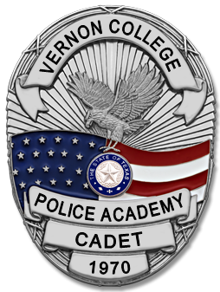

**Vernon College**

**Law Enforcement Academy Packet**

**2022 - 2023 Class 46th Academy**

**Application is CLOSED;**

**We will start recruiting in June 2023.**